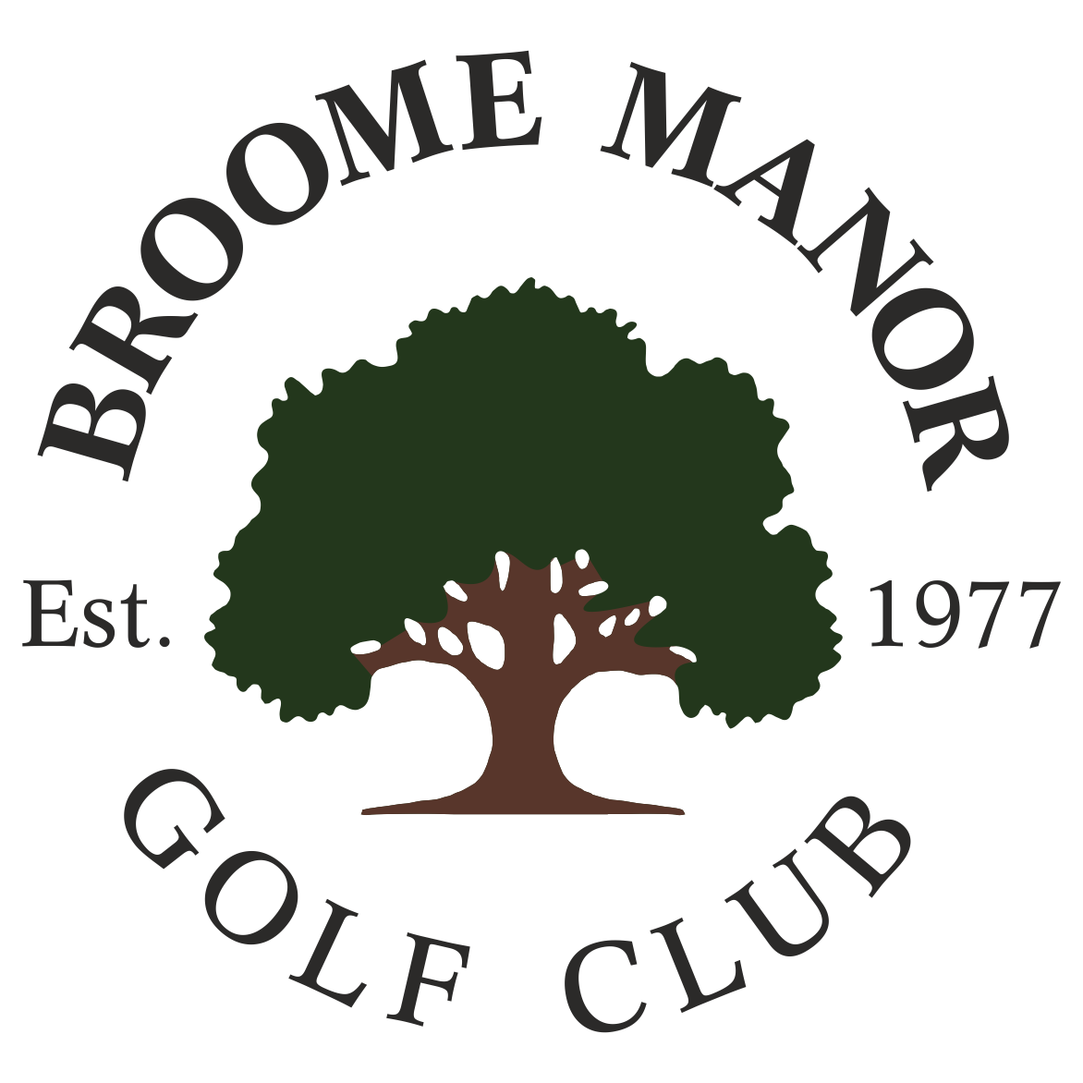
Broome Manor Golf Club

SENIOR OPEN COMPETITION
Organised by the Senior Section

Thursday 7th May 2026

ENTRY FEE £32 INCLUDES BACON ROLL WITH TEA OR COFFEE (TO BE TAKEN BEFORE PLAY) AND 2s COMPETITION FOR SLEEVE OF GOLF BALLS

FORMAT
18 HOLE STABLEFORD. 95%HANDICAP ALLOWANCE AND MAXIMUM PLAYING HANDICAP FOR PRIZES OF 28. PLAYERS OVER 28 ARE MORE THAN WELCOME

PRIZES
OVERALL BEST NET SCORE
TOP 3 PRIZES IN 2 DIVISIONS
NEAREST THE PIN

IF YOU WISH ENTER PLEASE E-MAIL bmgcopens@gmail.com WITH YOUR NAME, CLUB, AND CDH NUMBER. CONFIRMATION RE YOUR PLACE AND FURTHER DETAILS REGARDING PAYMENT WILL THEN BE PROVIDED

