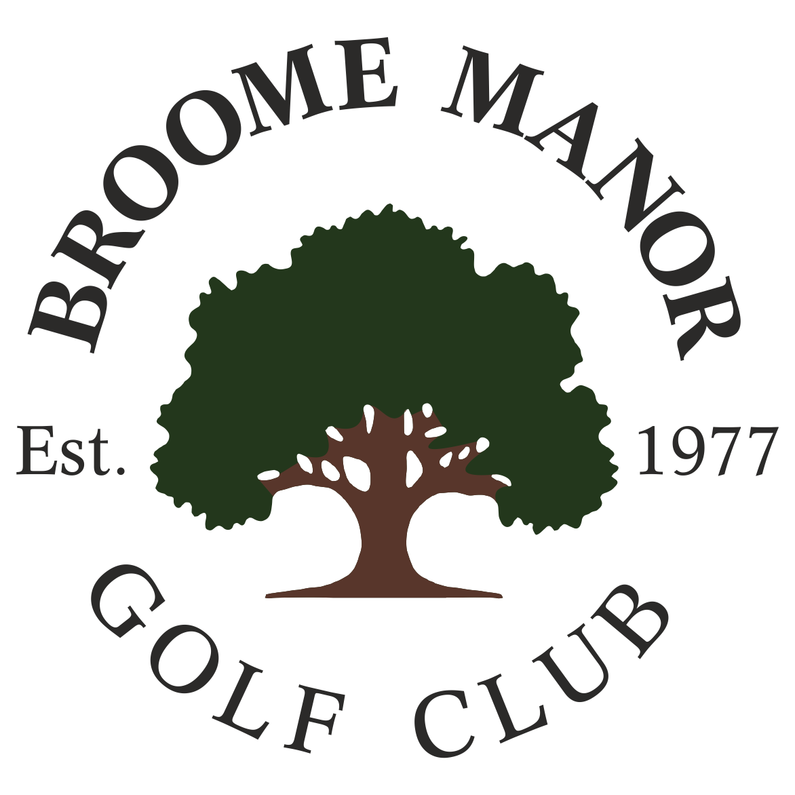
Broome Manor Golf Club

TEAM OPEN/AM-AM COMPETITION
Organised by the Senior Section

Monday 3rd August 2026

ENTRY FEE £35 PER PERSON FOR VISITORS AND BROOME MANOR COMPLEX NON PASSPORT HOLDERS INCLUDES BREAKFAST WITH TEA OR COFFEE (TO BE TAKEN BEFORE PLAY)

FORMAT
STABLEFORD. BEST 2 SCORES TO COUNT ON EACH HOLE AND 3 SCORES TO COUNT ON PAR 3s.
HANDICAP INDEX LIMIT 36 (MEN) AND 45 (LADIES).
OPEN TO ALL AGE GROUPS

PRIZES
OVERALL BEST TEAM SCORE, 1st, 2nd AND 3rd. NEAREST THE PIN AND LONGEST DRIVE FOR BOTH MEN AND LADIES

IF YOU WISH ENTER PLEASE E-MAIL bmgcopens@gmail.com WITH YOUR NAME, CLUB, AND CDH NUMBER. CONFIRMATION RE YOUR PLACE AND FURTHER DETAILS REGARDING PAYMENT WILL THEN BE PROVIDED

